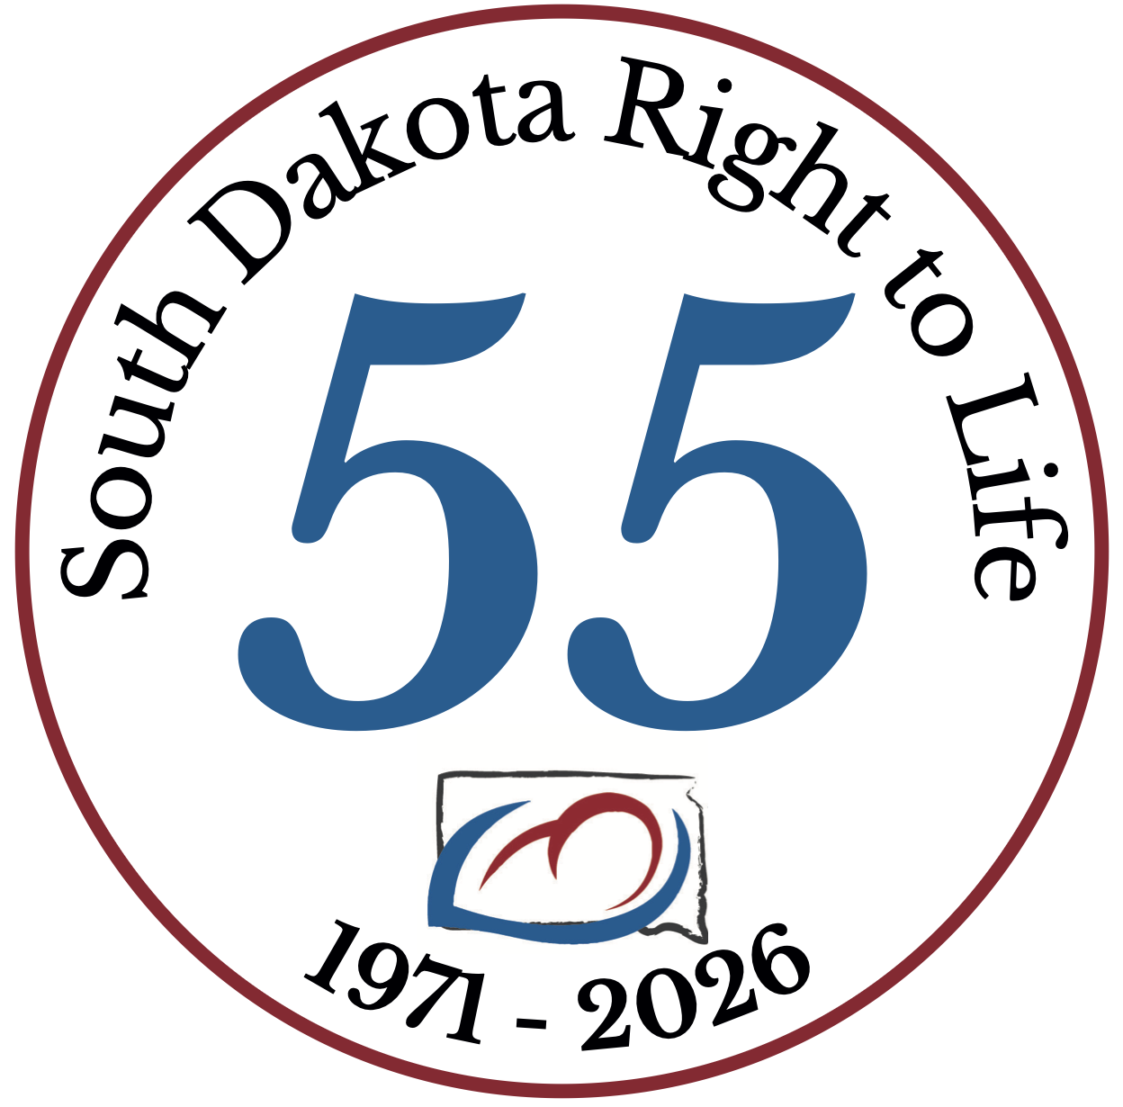
South Dakota Right to Life
Respectfully Requests
Your Voting ‘YES’
On
HB 1127
An Act to revise provisions related to birth centers and the practice of certified
professional midwives at birth centers.

~ The Debbie Pease Legacy Bill ~
Debbie Pease, President of the SDRTL Board of Directors, unexpectedly passed from this life to her Eternal Home on Friday, May 10, 2024. While we were stunned at this news and found ourselves often at a loss for words this we know - SDRTL had thrived under Debbie’s amazing years of leadership. She was the 'tip of our spear' and led us with a Christ-like spirit of love and compassion. All that she accomplished she did so with a flare of excellence.
We believe that God danced the day Debbie was born and then God danced the day He welcomed Debbie to her Heavenly home.
Debbie Pease, our Sister in Christ, Friend and Colleague will be missed and never forgotten. May she rest eternally in the loving arms of her Lord and Savior surrounded by the millions of unborn babies she so defended and loved.
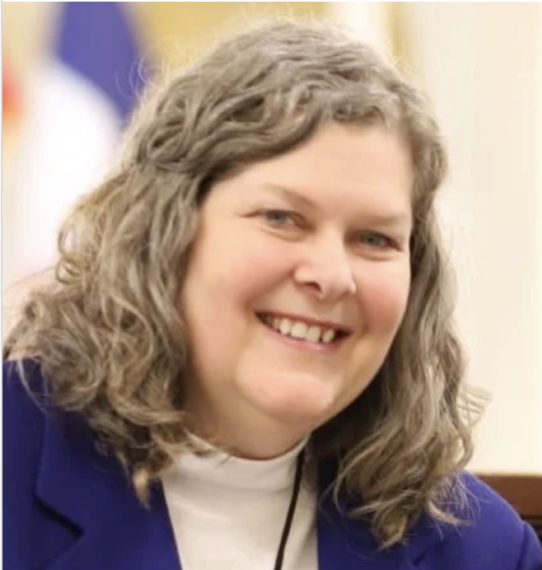
NOTE: In addition to Debbie’s passionate work with South Dakota Right to Life she lobbied for years with the organization – BIRTH MATTERS. The content of this Bill -- HB1127 -- was dear and near to Debbie’s heart. There are many areas in South Dakota that can be categorized as “maternity deserts.” These areas, with no nearby hospitals, offer no maternity options to mothers in South Dakota. HB1127 could help remedy this problem, by enabling certified professional midwives (CPM’s) to supervise birth centers in the state.

